**1). Write a shell script program that check whether entered number is leap or not.**

echo "Enter the year"

read year

if [ $year -ge 1000 -a $year -le 9999 ];

then

if [ `expr $year % 4` -eq 0 ]

then

echo "The year $year is a leap year"

else

echo "The year $year is not a leap year"

fi

fi

**OUTPUT**

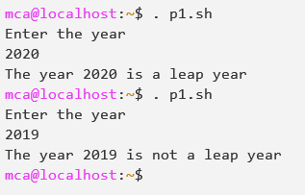

**2). Write a program to find the total number of users logged in.**

echo -e "\nProgram to find the total number of users logged in.\n"

echo "Total number of users: "

users | wc -w

echo -e ""

**OUTPUT**

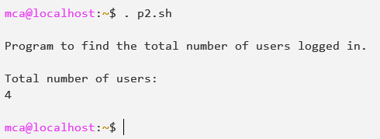

**3). Write a shell script to calculate the gross salary. Take a basic from keyboard DA=100%, HRA=30%, income tax deduction Rs. 2000.**

echo -e "\nProgram to calculate Gross Salary\n"

echo -e "Enter your Basic Salary:"

read basic

echo -e "Basic Salary: $basic"

da=`expr $basic \* 2`

echo -e "Dearness Allowance: $basic"

hra=`expr $basic \* 30`

hra=`expr $hra / 100`

echo -e "House Rent Allowance: $hra"

total=`expr $da + $hra`

total=`expr $total - 2000`

echo -e "Deduct Rs 2000 of income tax"

echo -e "\nGross Salary: $total\n"

**OUTPUT**

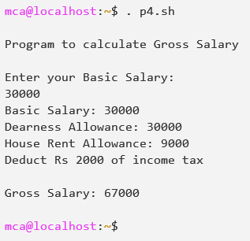

**4). Write a shell script to find out simple interest and total amount after 5 years for a principal value entered by the user. ROI 15%.**

echo -e "\nProgram to calculate simple interest\n"

echo "Enter the Principal Amount: "

read principal

echo -e "\nPrincipal Amount: $principal"

roi=`expr $principal \* 15 / 100`

echo -e "Interest: $roi"

si=`expr $roi \* 5`

echo -e "\nSimple Interest: $si"

t_amt=`expr $principal + $si`

echo -e "\nTotal Amount: $t_amt\n"

**OUTPUT**

